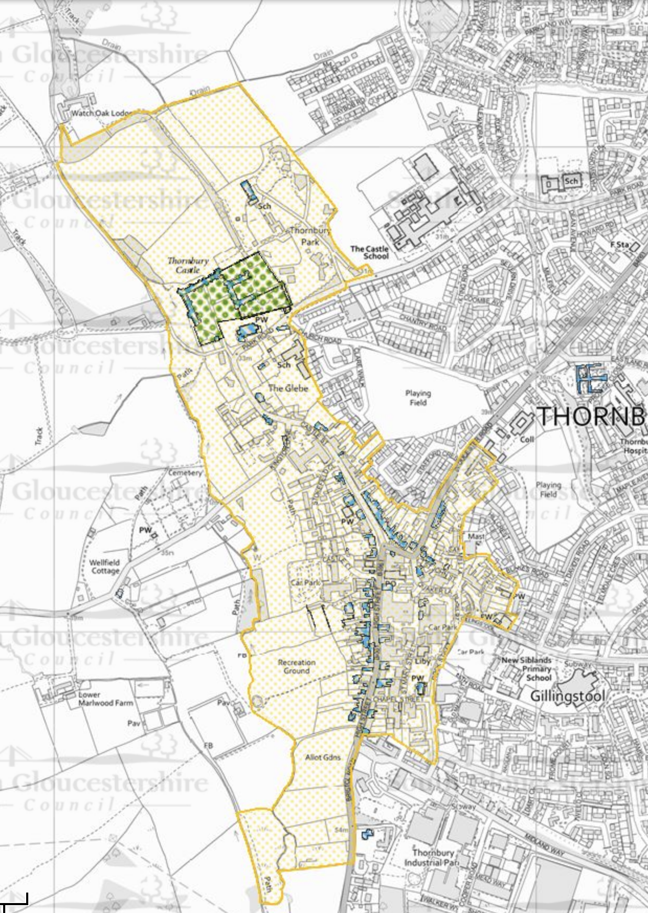

Appendix 1- Thornbury Conservation Area

