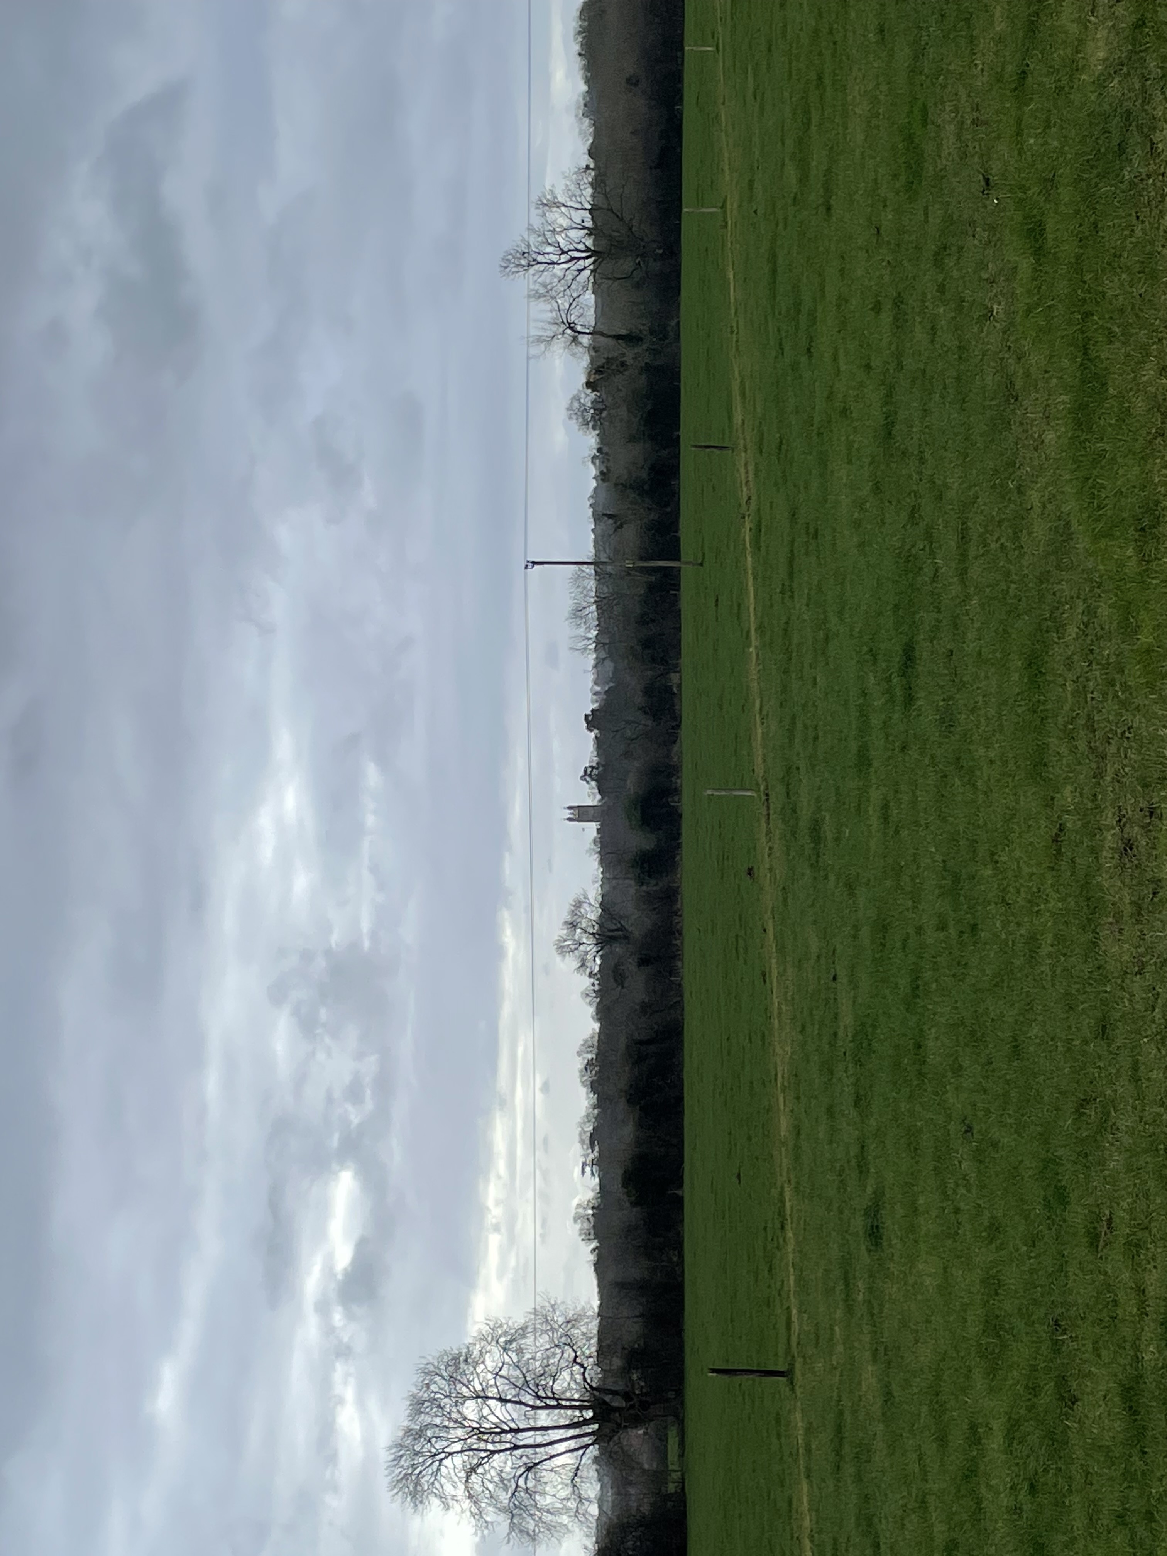
Appendix 6- view over appeal site to Thornbury Castle, St Mary’s church, Sheiling School and Thornbury conservation area, from Oldbury Lane

