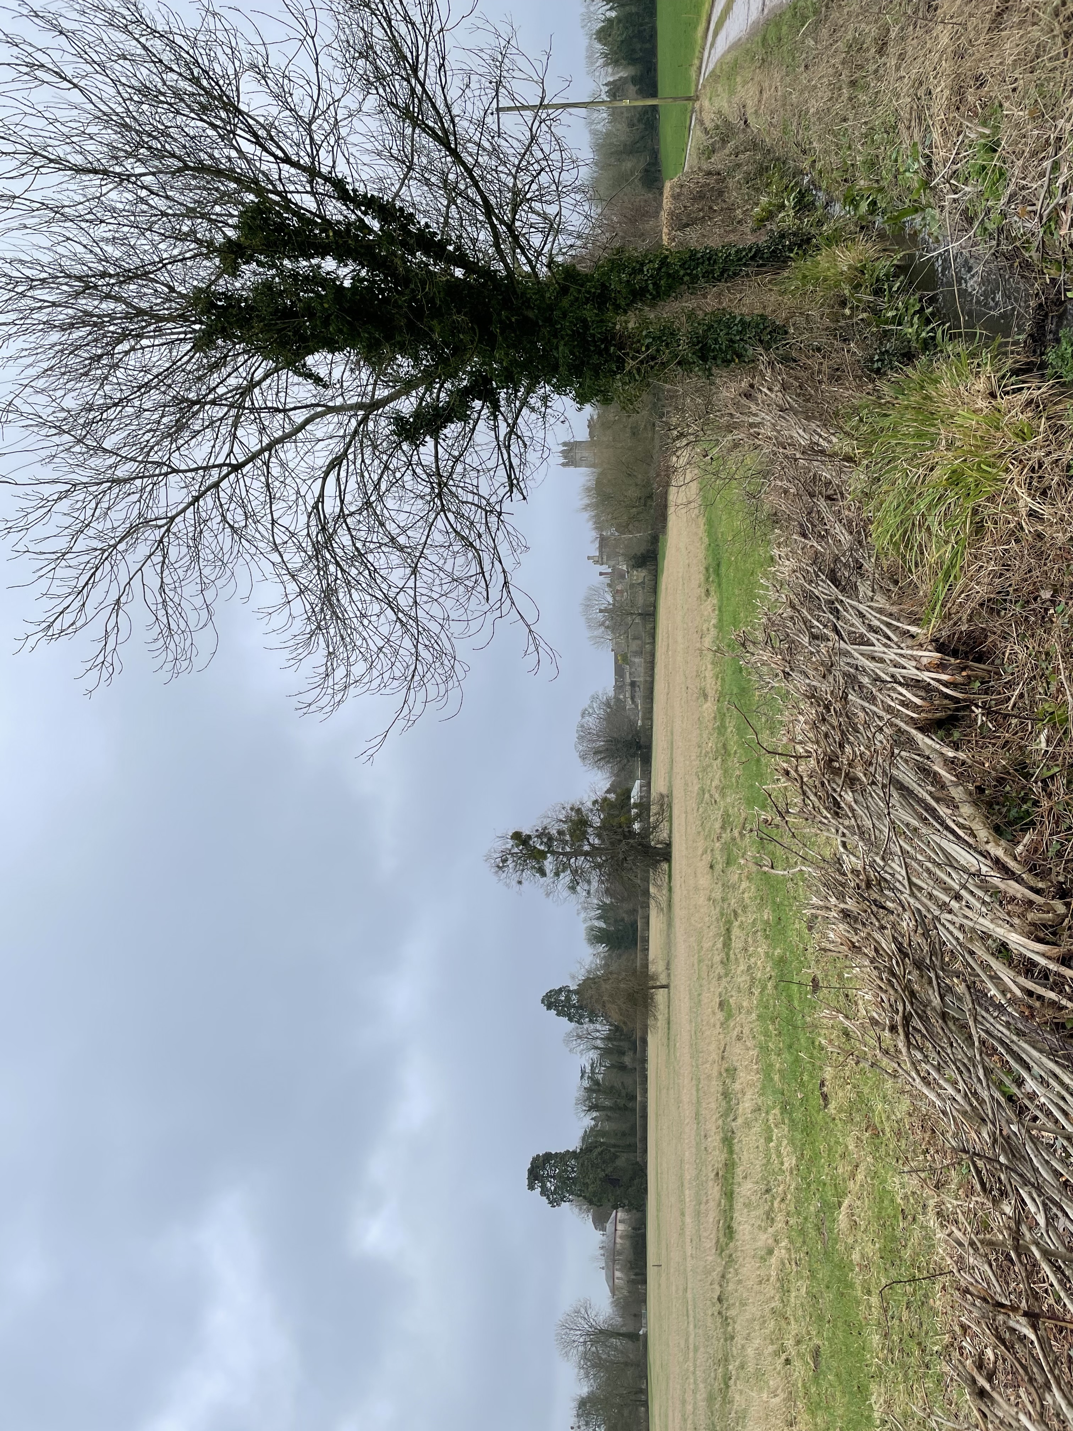
Appendix 4- view of assemblage of heritage assets from public footpath north west of Thornbury Castle

