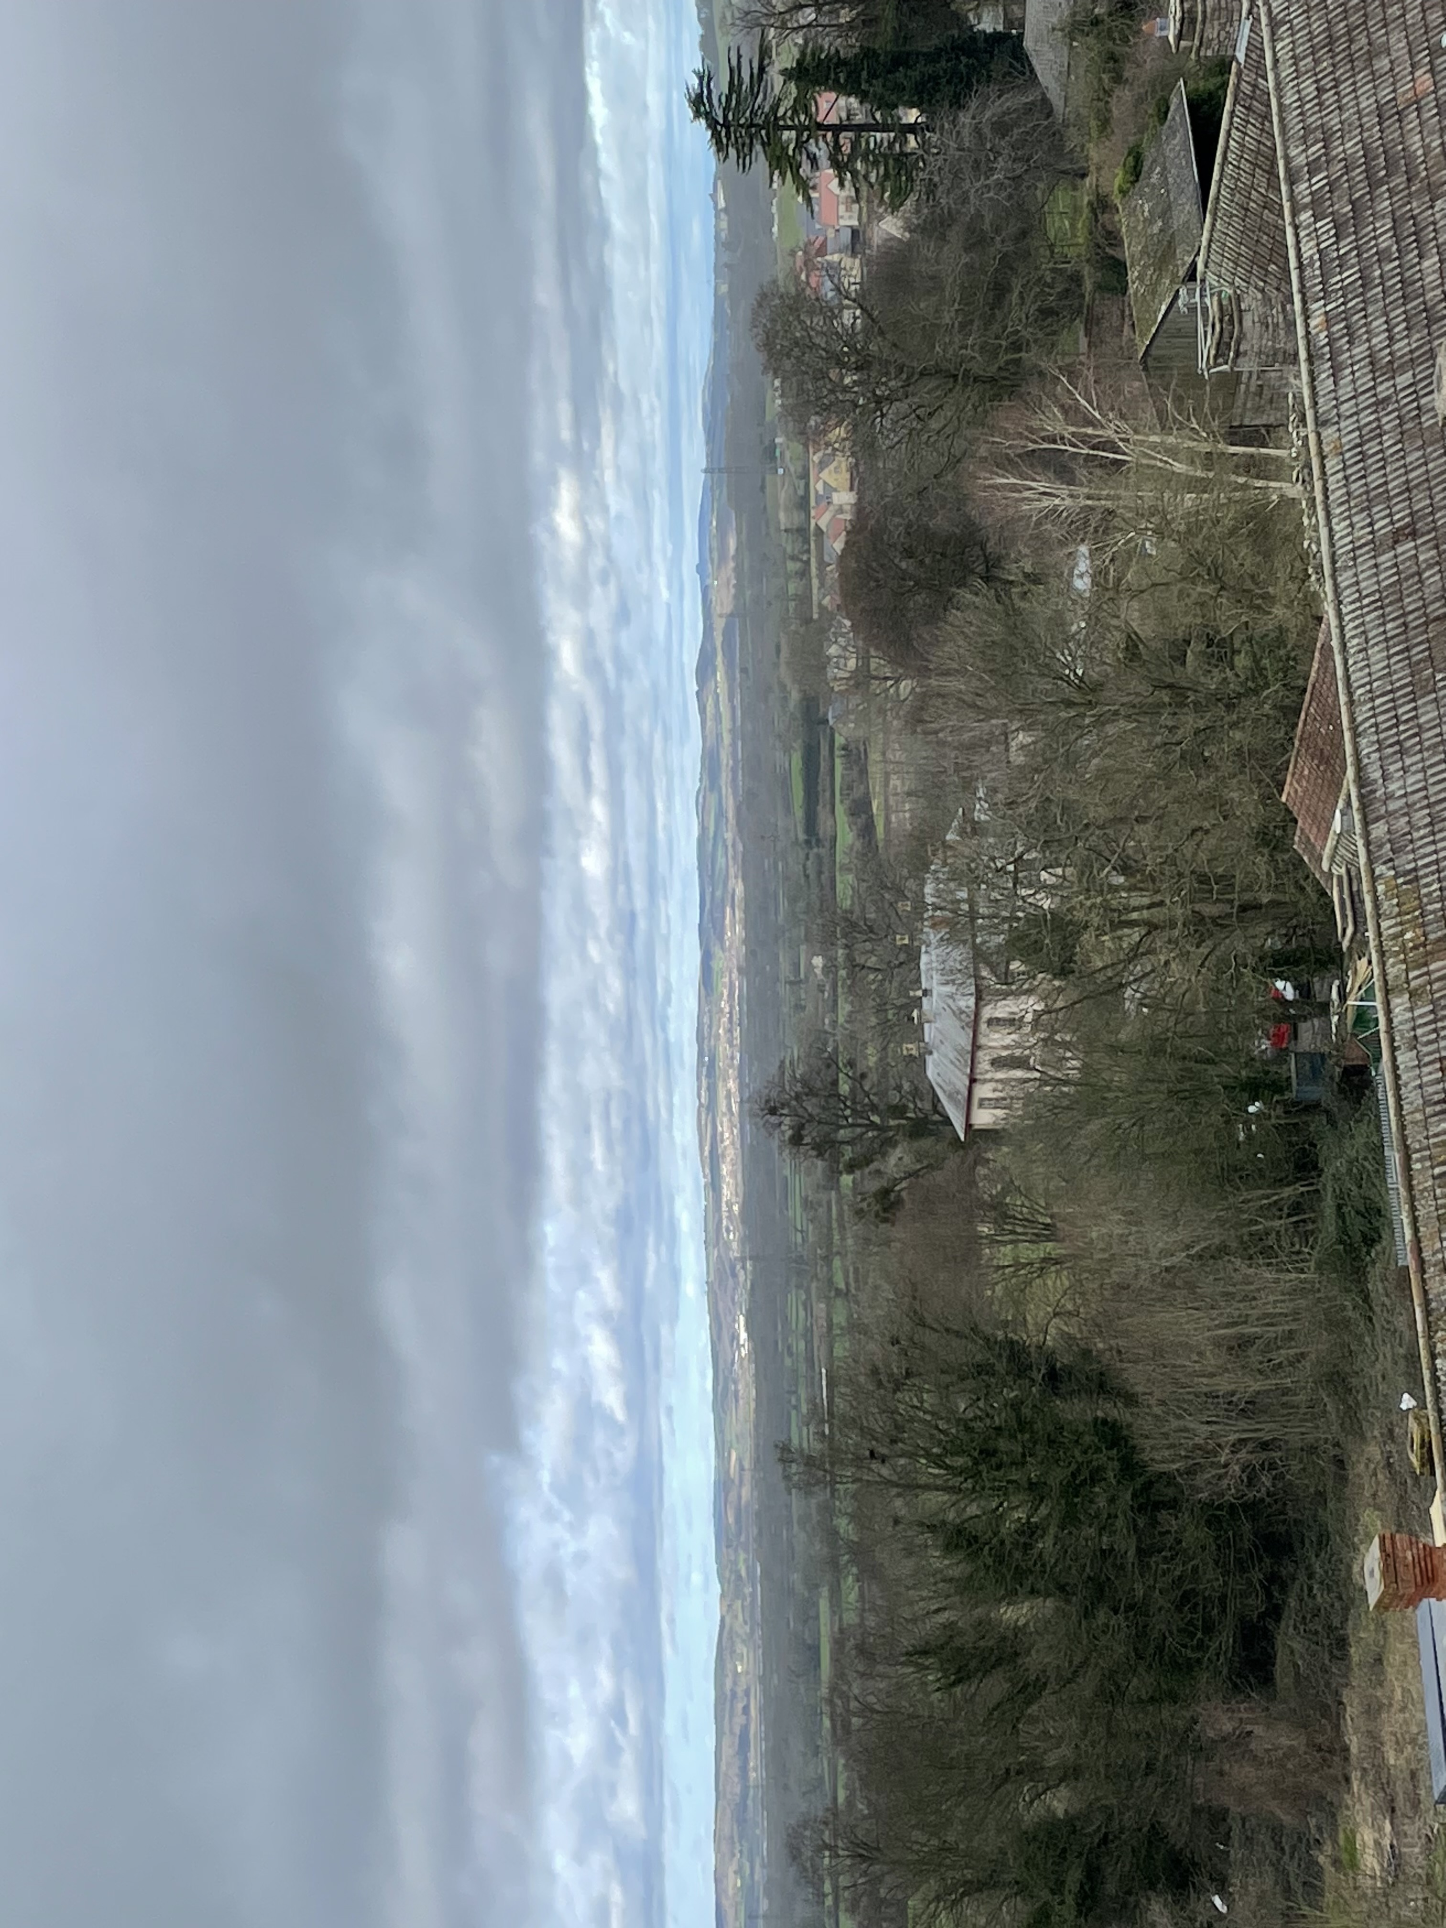
Appendix 5- view towards appeal site, from roof of Thornbury Castle

