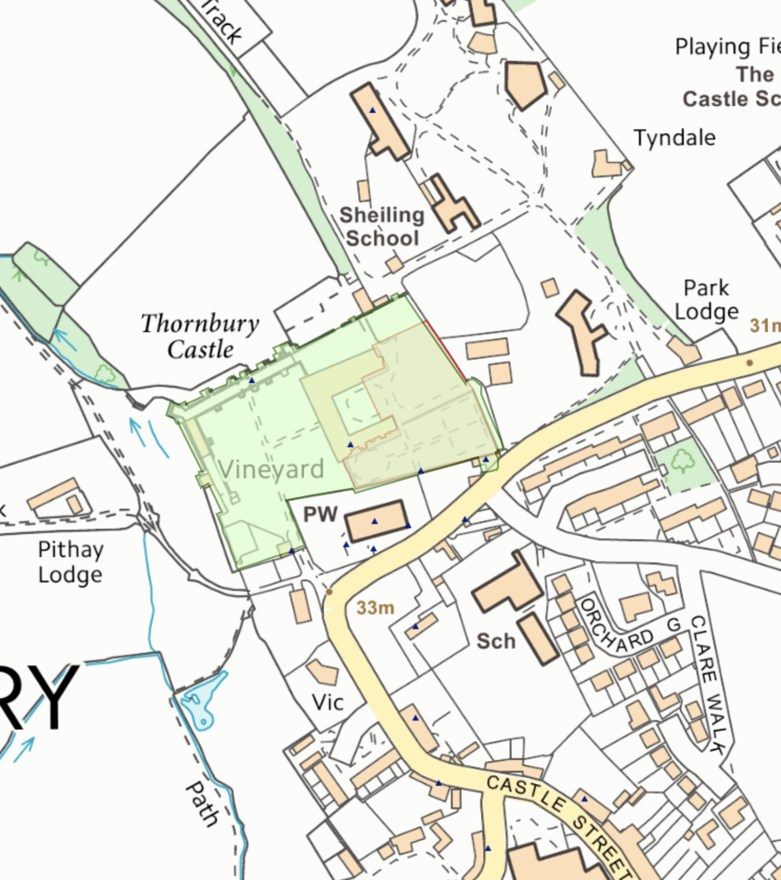
Appendix 2- Plan from National Heritage List showing location of listed buildings (blue triangles), registered park and garden (green tone at Thornbury Castle), and scheduled monument (outlined in red)

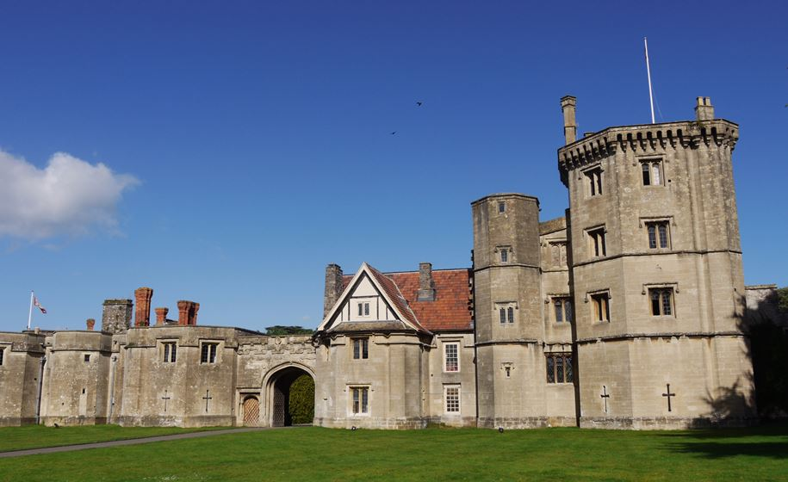
Thornbury Castle Inner Court

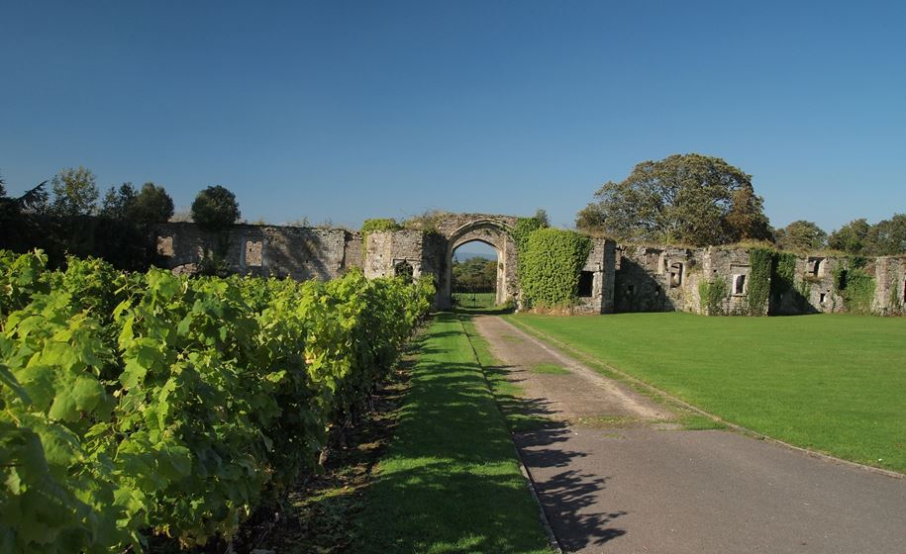
Thornbury Castle Outer Court

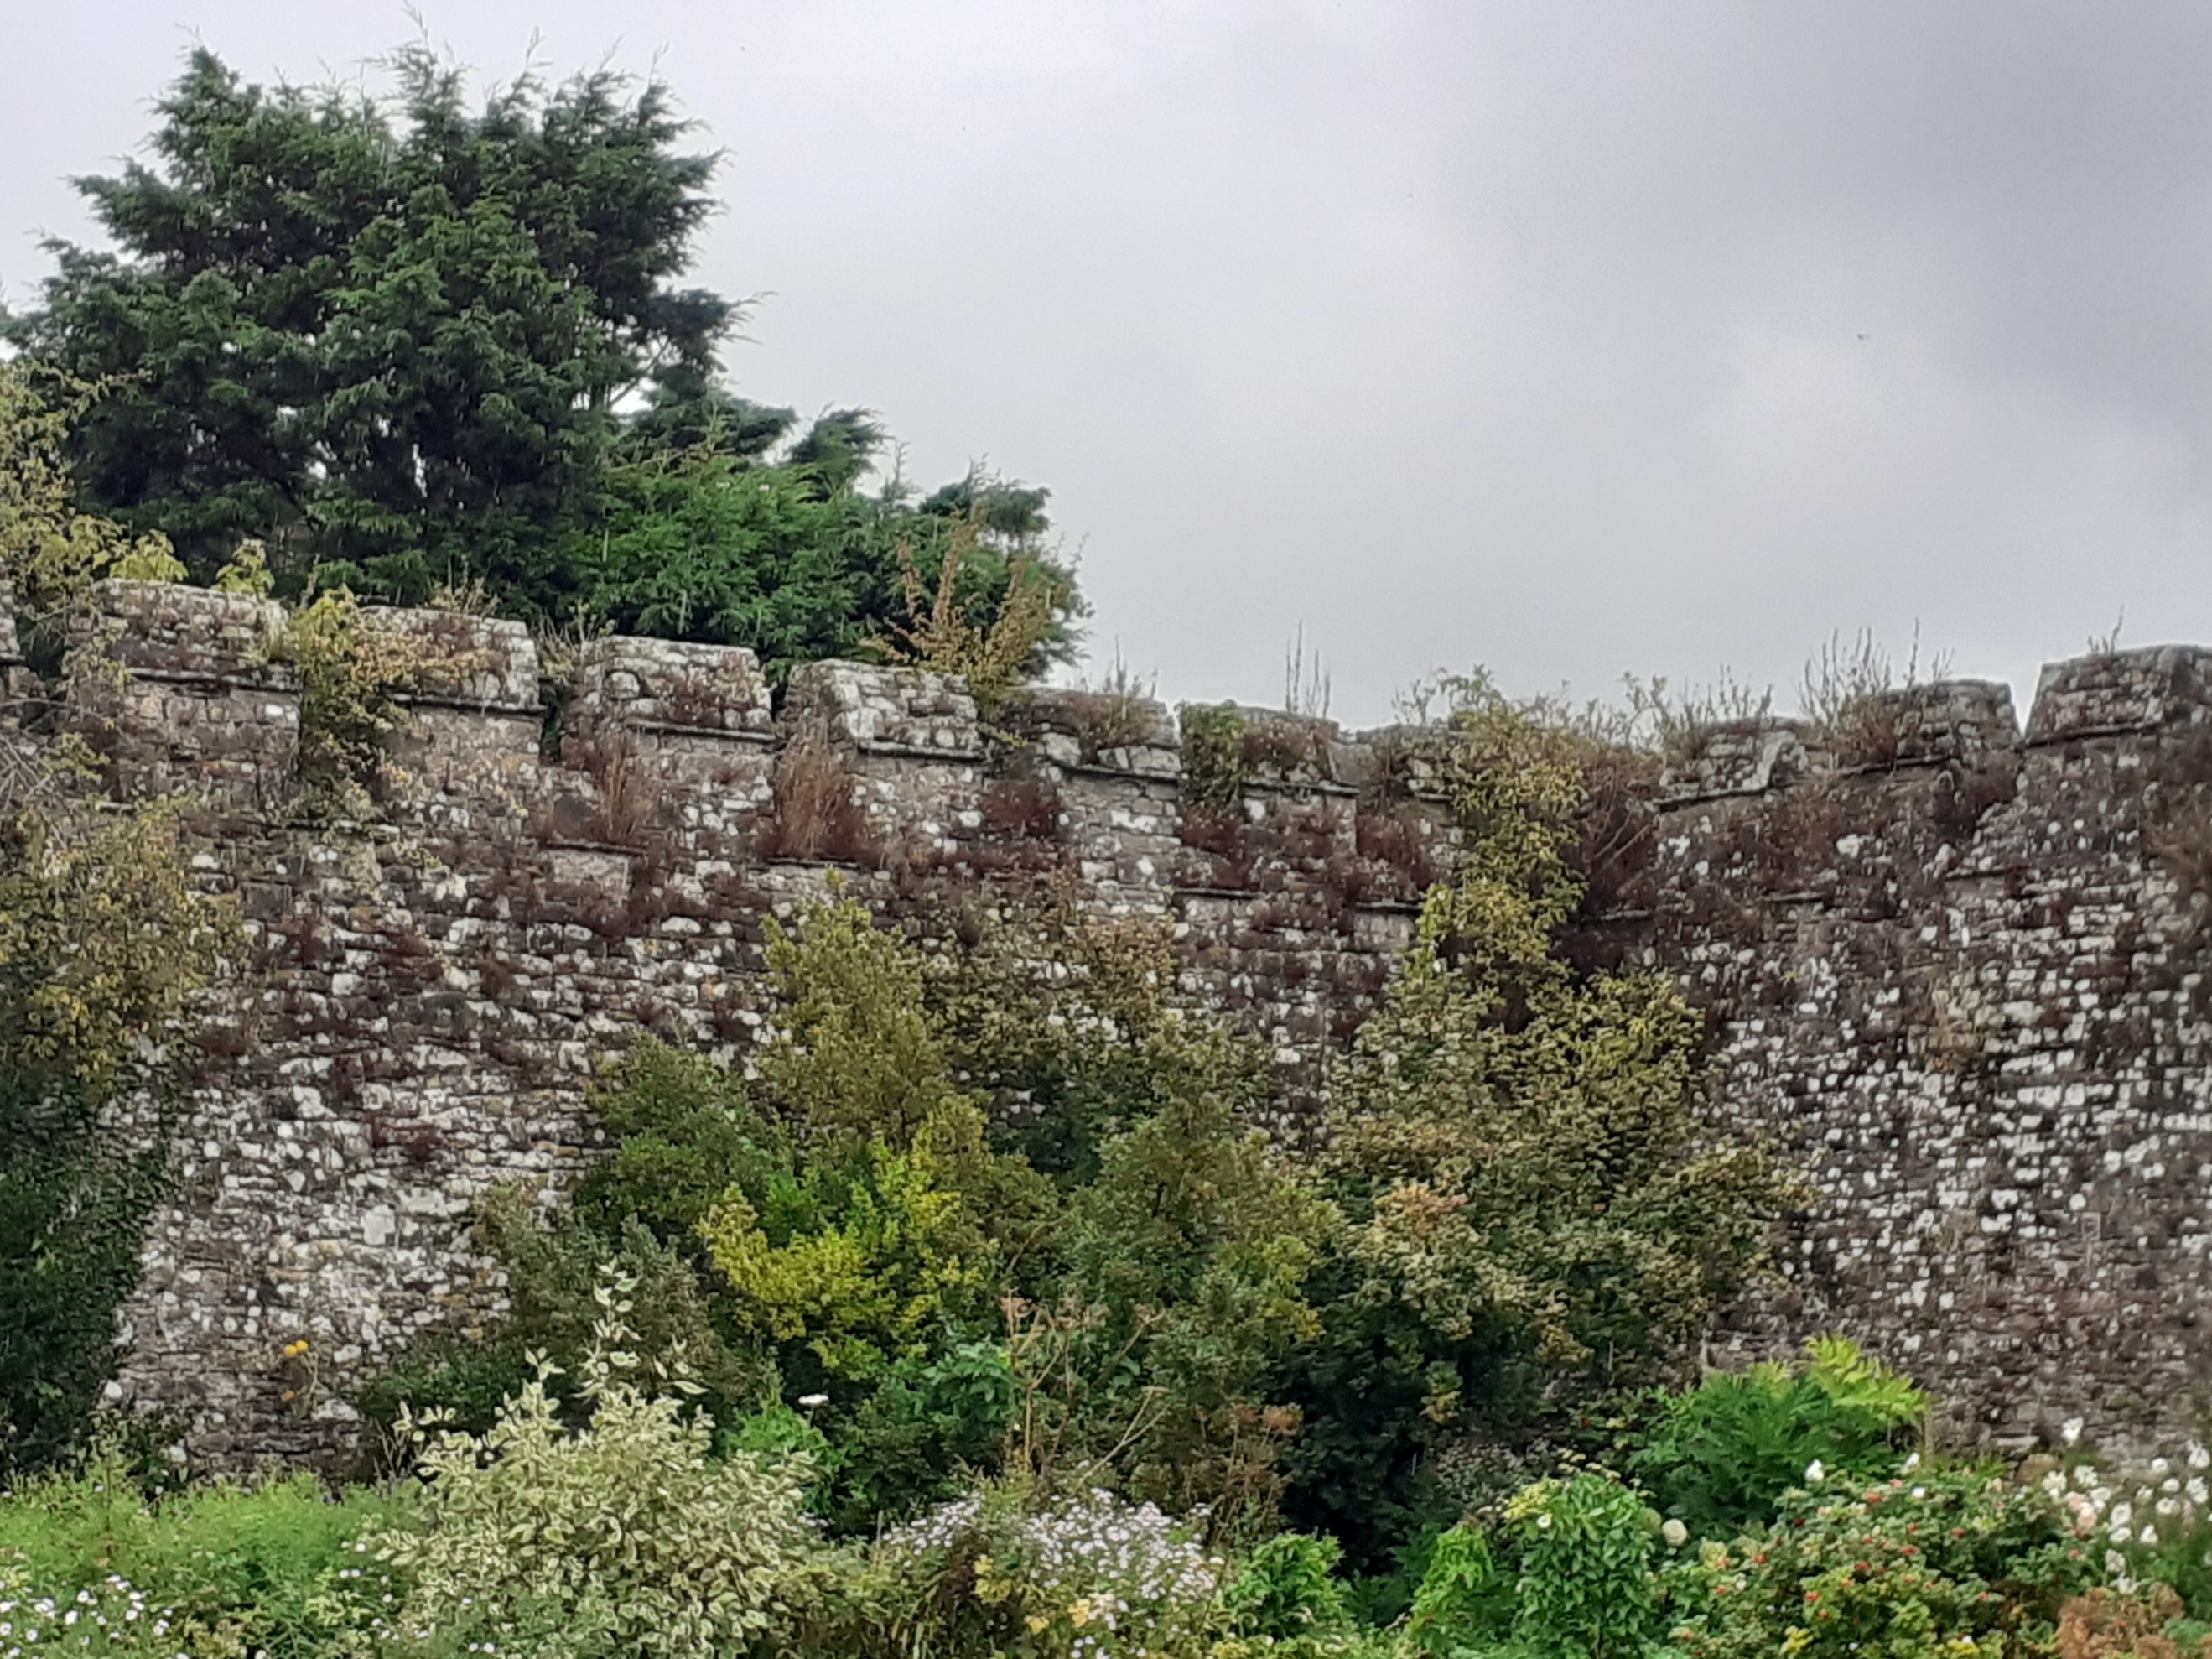
Thornbury Castle- Privy Court

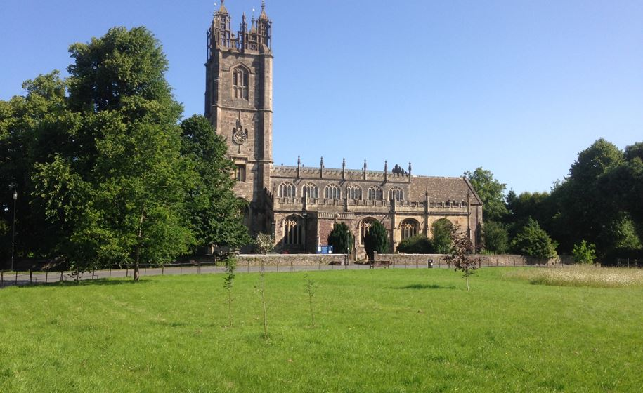
Thornbury- St Mary’s Church

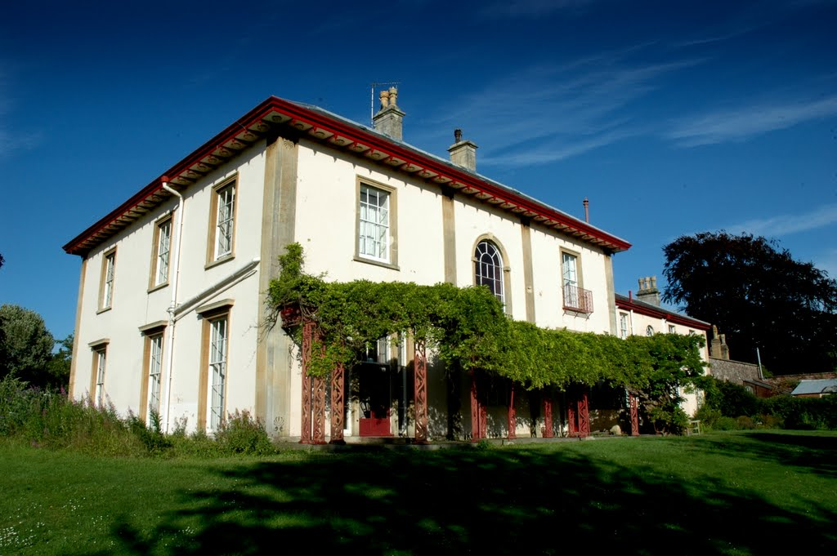
Thornbury- Sheiling School

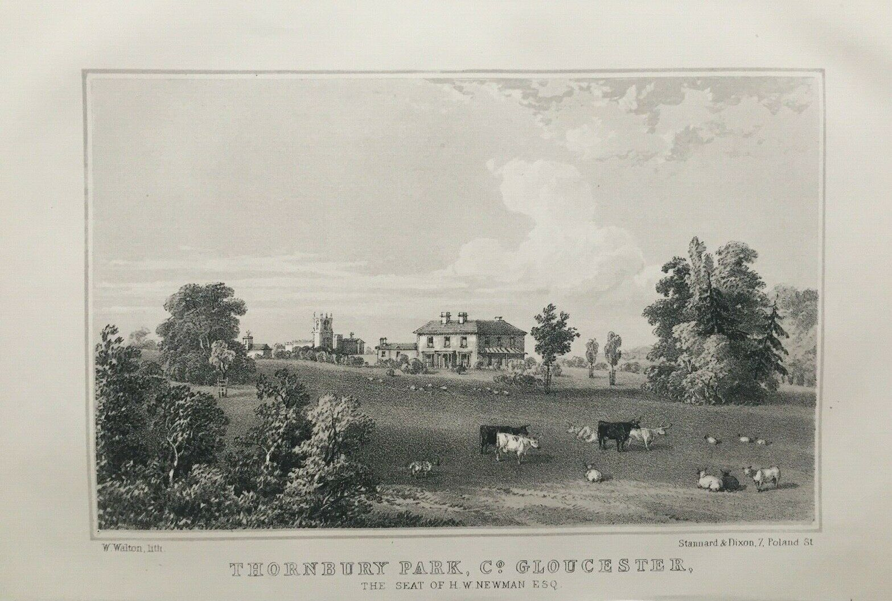
Thornbury Park (Sheiling School) 1854, with parkland

