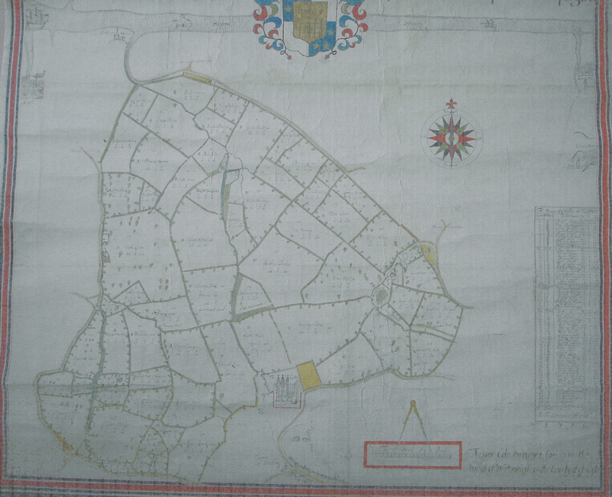
Appendix 7- Estate Map of 1716

